**First boot (32,85s, 919ms,2.72s).**



The longest uploaded file is an image. Not the heaviest (451Kb), loaded in 2.42 sec.

Compared to the heaviest one (1.9Mb), the 451Kb image had a loading priority (Queueing = 0.47 ms vs 896.45 ms), but at the same time, the initial connection and ssl protocol took longer (226.47+113, 51 vs 0+1.24). The reason may be server load...

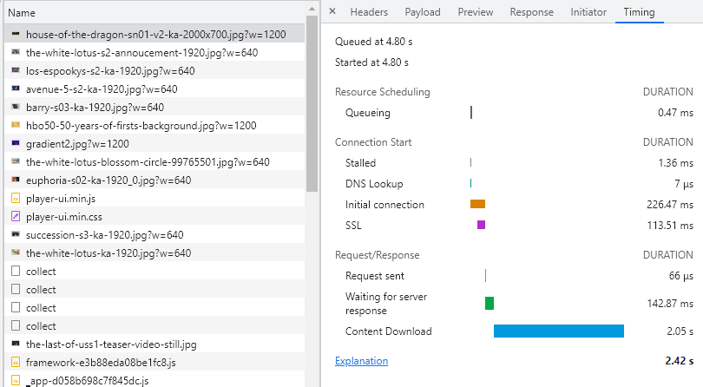

The heaviest file 1.9 Mb downloaded in 0.363 seconds, although the timing tab shows that the download took 1.26 seconds.

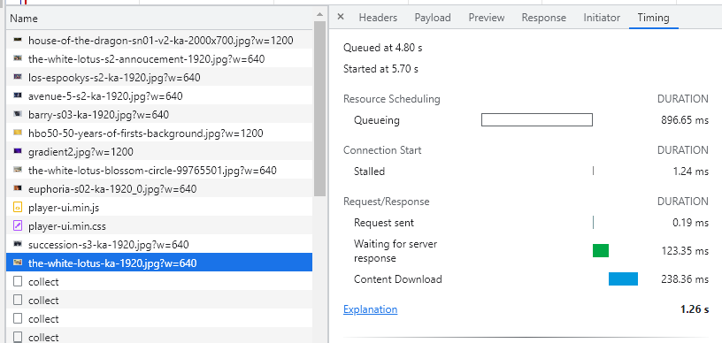

**Second boot (6.4s, 801ms,1.10s).**

Faster loading is due to the fact that the bulk of the data was loaded from the cache. The maximum size of the uploaded file is 2.0Kb vs 1.9Mb at initial upload.